Name

Air Pollution Sources in My Community

**Directions:**

1. Using your computer, go to the website: <https://tinyurl.com/DCMetroAirPollution>. You should see a spreadsheet of information that looks like this:

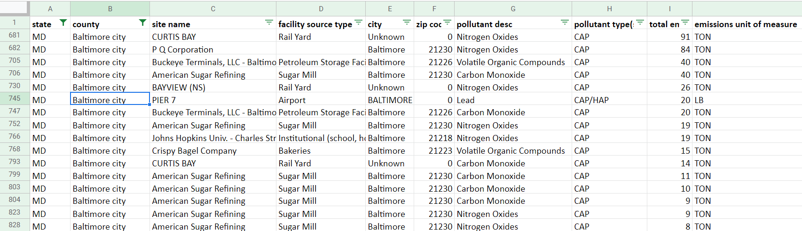

This is a list of all the pollution sources in Maryland, Virginia, Washington DC, and West Virginia. Make sure you are on the tab for Criteria Pollutants (look at the bottom).

1. To find pollution sources in your neighborhood, start by sorting the list by zip code. You can do that by clicking on the little triangle next to zip code that looks like this:

Then click Sort A🡪Z. This will sort the list by zip code.

1. Now you can scroll through the list to find your zip code. You can also search for your zip code by holding <control>-F, typing your zip code into the box that pops up, and hitting enter. When you find some entries in the list for your zip code, go to the next step. If you can’t find anything in your zip code, use one that has a similar number.

STUDENT

GUIDE

1. When you find some emissions sources in your zip code or one nearby, look in the column for “total emissions” (it is the next to last column). This is the amount of emissions that come from that source. Find the source with the most emissions in your area.
2. Write down the following information for that source in your data table on the next page:

* **The site name**: this is the name of the company or organization
* **Type**: this is what the company or organization does
* **Pollutant**
* **Total emissions**

1. Find at least four other sources of pollution in your neighborhood, and add their information to your data table. Look for sites you recognize from your neighborhood, and sites that have a lot of emissions.

Pollution Sources

|  |  |  |  |
| --- | --- | --- | --- |
| Site Name | Type | Pollutant | Total emissions |
|  |  |  |  |
|  |  |  |  |
|  |  |  |  |
|  |  |  |  |
|  |  |  |  |
|  |  |  |  |
|  |  |  |  |
|  |  |  |  |

Analysis

What “type” of polluter is most common in your area?

What pollutant was most common in your area?

Sort the database by total emissions by clicking the arrow next to total emissions and choosing “sort Z🡪A”. When the database is sorted, look at the top 10 polluters.

What “type” of industry creates the most pollution?

What pollutants are most common from this industry?

How do the polluters in your area compare to the biggest polluters? Do the emit a lot or a little pollution in comparison?